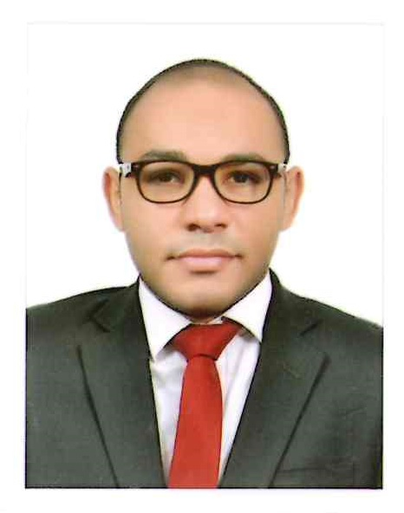 ***Hazem Mabrouk***

**Assoc CIPD**

**Dubai, United Arab Emirates**

**Mobile: (+971)561679685**

[**Mabrouk.hazem@gmail.co**](mailto:Mabrouk.hazem@gmail.co)**m**

* A triple major graduate bearing vast academic and professional knowledge in medical, human resources and education fields.
* I am looking forward to building a career that matches my qualifications and my experience within a leading organization, being a professionally qualified senior L&D proffessional with (8+) years of experience in customer services and business in robust multinational environments. Along with well-developed academic studies in the field of Training, recruitment, human resources management and ELT.
* Conceptualizing & developing training & development initiatives for improved productivity, building capability and quality enhancement; organizing training programs of internal & external agencies, developing multi skills as per defined standards especially in Medical field or ELT.
* Identifying training needs across levels through mapping of skills required for particular positions and analysis of the existing level of competencies.



**Work Experiences  **

**Teleperformance GCC**

* **Aug 2020 Till now:** 
  + **Position: Training Assistant Manager**



**Duties and Responsibilities:**

* Managing a team of 7 trainers

* Reporting and leadership

* connecting with senior leadership and provide consultancy

* attending business review meeting and strategy alignment

* **01 Dec 2018 Till Aug 2020:** 
  + **Position: Trainer**

**Duties and Responsibilities:**

* Responsible for new hires and existing employees training and continuous learning process.

* SPOC of Knowledge and Processes that are being run in the Ministry

* Soft skills and business demand trainer

* UAE Labor Law – Emaratization “Tawteen Trainer”

* Lead Trainer for Contact Center Happiness centers including Chat – Email support and Social media.

*Maintained dashboards and all necessary training reports

*<eet with client and stakeholders for all training concerns and MBR

intelenet logo**Intelenet Global services**

* **01 July 2017 Till Dec 2018:** 
  + **Position: Master Trainer, L&D specialist**

**Duties and Responsibilities:**

* Responsible for new hires and existing employees training and continuous learning process.  
* Customer service oriented and customized training programs to meet the needs of the learning   
process.  
*Responsible for the learning and development of Medcare Hospitals and clinics in Dubai, Dubai   
Design District, Damac facility Management, and Dubai International Financial Center.



**National Bank of Abu Dhabi**

* **01 July 2014 Till June 2017:** 
  + **Position: Business Trainer**

**Duties and Responsibilities:**

* Responsible for developing, implementing & modifying training program to ensure effectiveness of programs delivered to call center/customer service personnel
* Identified individuals' progress and additional training need
* Developed program with new products and/or services
* Used questioning techniques (open, closed, directed) and training materials (leader guide, participant materials, job aids)
* Demonstrated verbal communication skills (grammar, volume, jargon-free, tone & tempo), presentation skills (eye contact, body language & non-verbal), writing skills (grammar & spelling) and high degree of professionalism, flexibility & integrity
* Analyzed learner needs (clarification, examples, feedback, coaching and listening)



**Vodafone International Services**

* **01 July 2010 - June 2014 :** 
  + **Position: Soft Skills and technical Trainer UK account**

**Duties and Responsibilities:**

* Responsible for developing, implementing & modifying training program to ensure effectiveness of programs delivered to call center/customer service personnel
* Identified individuals' progress and additional training needs
* Developed program with new products and/or services
* Used questioning techniques (open, closed, directed) and training materials (leader guide, participant materials, job aids)
* Carried out activities such as simulations, breakout rooms, quizzing, etc.
* Demonstrated verbal communication skills (grammar, volume, jargon-free, tone & tempo), presentation skills (eye contact, body language & non-verbal), writing skills (grammar & spelling) and high degree of professionalism, flexibility & integrity
* Analyzed learner needs (clarification, examples, feedback, coaching and listening)

**Major Achievements:**

* Achieving best employee with highest end year appraisal rated (exceptional performance)
* Achieving best results with the team enrolled for ER (Emergency Room Model)
* Awarded entrepreneur YLI program from Vodafone nominated for “achieving a personal victory and communicating for impact “



**Vodafone International Services**

* **01 October 2008 - June 2010:** 
  + **Position: Contact Center Advisor**

**Duties and Responsibilities:**

* Answer Customer Queries and help with solving their product related issues
* Achieve call center KPI’s according to KPI’s Matrix
* Conduct and prepare Briefings on Daily Basis
* Manage team delegation upon team managers leaves.

**Freelance Trainer – Part Time (2008 till Now)**

* TOT (Training of Trainers)
* English Trainer (General Egyptian society for talented welfare)
* Project Management
* In Life Coaching
* Strategic Management
* Intellectual and communication skills (Sira Academy)
* Presentation Skills
* Medical English Trainer
* Private Academic Tutor ``





**[August 2016] The Cambridge Certificate of English Language Teaching For Adults**

* Grade: Pass, Awarded from the British Council in Abu Dhabi, UAE

**[2011-2012] Human Recourses Management post graduate diploma, AUC, Cairo**

**-Courses**

* Recruitment and Talent acquisition
* Training and development.
* Performance management and assessment
* Compensation, benefits and HRIS

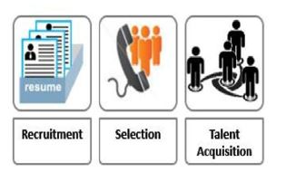**[2010-2011] Training of Trainers post graduate diploma, AUC, Cairo**

**-Courses**

* Training needs analysis (TNA)
* Training venue management and Training tools
* Return on Investment (ROI)

**[2004-2010] B.Sc. of Clinical Pharmacy &pharmaceutical sciences, Ain Shams University, Cairo, Egypt.**

**-Courses include:**

* Clinical Pharmacy practice
* Patient Counseling
* Marketing
* Pharmacology
* Medicinal Photochemistry
* Microbiology
* Pharmaceutics, Analytical, and pharmaceutical Chemistry

**Grade:** Good with Honors



* **Skills**
* **Communication Skills:** 
  + Effective Communication and Training skills.
  + Core Values & code of Ethics
  + Develop leadership skills & Team building
  + Enhance communication skills
* **Computer Skills:**

• **Operating System**

Windows XP, Vista, Win 7, Win 10

* **Office Suits (ICDL)**

Office 2003/2007/2010, 2016

* **Software:**

CRM, RTM, HR SAP, ERP

* N+ (Microsoft Certified)
* A+ (Microsoft Certified)

|  |  |  |  |
| --- | --- | --- | --- |
| * **Language Skills:** | | |  |
|  |  |  |  |
| * **Arabic:** Native * **English:** Native Level (academic IELTS score:8) * **French**: Good Command | | |  |
|  |
|  | | |  |
|  |  |  |  |
| ➢ **Competences:** | | |  |
| • Ability to work well with all levels of management and personnel | | |  |

• To work as a key player in the challenging & creative environment.

• High-profile of interpersonal skills to handle sensitive and confidential situations and documentation.



Personal

|  |  |  |  |  |  |  |
| --- | --- | --- | --- | --- | --- | --- |
| • **Date of Birth** | | **:** | Jan.11th 1987 | • **Military Status :** Full Exemption | *Hazem Mabrouk.* | |
| • **Marital Status** | | **:** | Married | • **Driving license:** Available and valid |  |  |
|  |  |  |  |  |  |  |
|  |  |  |  |  | **| P a g e** | |